Eng. Ashraf Ali
Innovation and Entrepreneurship manager
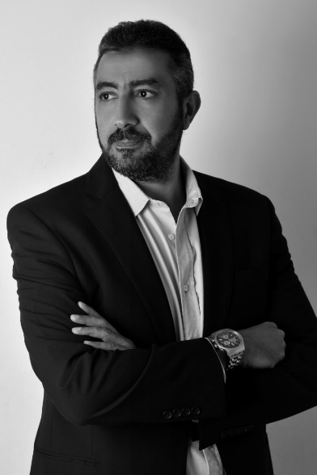
Ashraf has 20 years of extensive experience in ICT industries, got BSC in Electronics and communication from AAST. Has been working for Orange Business services for more than 14 years serving customers in different industries, that allows him to collect knowledge and experience on how business is done in these industries. Ashraf also holds an MBA from Manchester Business School and since 2015 he was working as Business Strategist for different companies and project, he was able to support and mentor more than 30 startups. Since he joined EiTESAL as Innovation and Entrepreneurship manager in 2017, Ashraf has designed many programs/projects to develop both entrepreneurship ecosystem and ICT industry in Egypt.

